Clause (Relative or Noun Clause) as Head

🟩 What is Clause (Relative / Noun Clause) as Head?
# Source: AI Source: Provided by: [Data Path: Persons Table -> ID Column: 1, Name_En Column: Motasem Essam] -> From: [Chatgpt (GPT‑5 Mini)] on [8/7/2025]
In syntax, when a clause functions as the head of a larger phrase, it means that the entire phrase is built around the clause, and the clause itself performs the main grammatical function. Two common types of such clause heads are:

🔹 1. Noun Clause as Head
# Source: AI Source: Provided by: [Data Path: Persons Table -> ID Column: 1, Name_En Column: Motasem Essam] -> From: [Chatgpt (GPT‑5 Mini)] on [8/7/2025]
A Noun Clause is a dependent clause that functions as a noun within a sentence. When a noun clause acts as the head of a phrase, it typically serves as the subject, object, or complement.
✅ Examples:
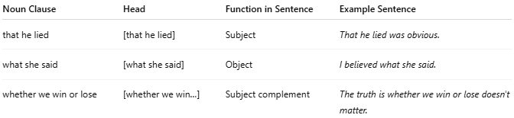
Noun Clause | Head | Function in Sentence | Example Sentence
that he lied | [that he lied] | Subject | That he lied was obvious.
what she said | [what she said] | Object | I believed what she said.
whether we win or lose | [whether we win…] | Subject complement | The truth is whether we win or lose doesn't matter.
- In all these cases, the clause itself (e.g., that he lied) is the head of a noun clause phrase.

🔹 2. Relative Clause as Head
This is less common but can appear in specific grammatical frameworks. A Relative Clause typically modifies a noun, but in some structures (especially in cleft constructions or free relative clauses), the relative clause acts as the head of the phrase.
✅ Examples:
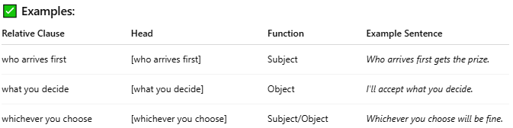
Relative Clause | Head | Function | Example Sentence
who arrives first | [who arrives first] | Subject | Who arrives first gets the prize.
what you decide | [what you decide] | Object | I'll accept what you decide.
whichever you choose | [whichever you choose] | Subject/Object | Whichever you choose will be fine.
These are sometimes called free relatives — they act like noun phrases, and the clause itself is the head.

✅ Summary Table
# Source: AI Source: Provided by: [Data Path: Persons Table -> ID Column: 1, Name_En Column: Motasem Essam] -> From: [Chatgpt (GPT‑5 Mini)] on [8/7/2025]
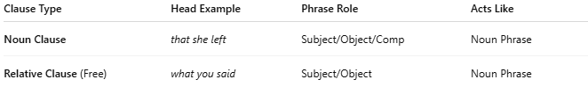
Clause Type | Head Example | Phrase Role | Acts Like
Noun Clause | that she left | Subject/Object/Comp | Noun Phrase
Relative Clause (Free) | what you said | Subject/Object | Noun Phrase

